Media:
Nicole Dufour
CPR Communications
ndufour@cpronline.com
201.641.1911 x 54

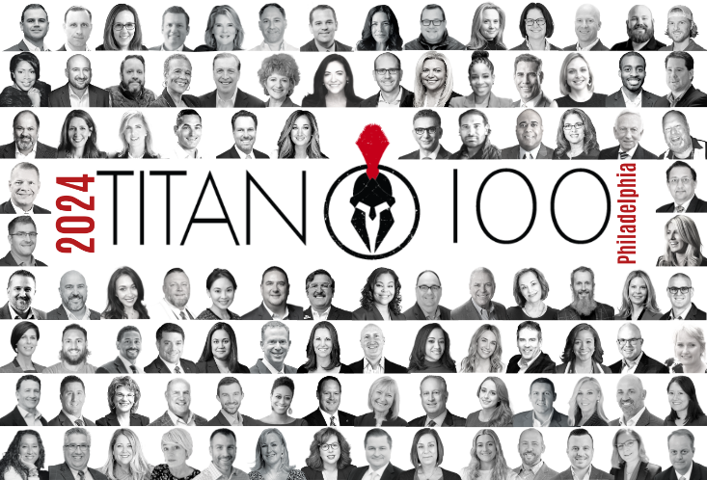

AscellaHealth Chairman and President Bill Oldham Named 2024 Philadelphia Titan 100

Berwyn, PA – June 13, 2024–Titan CEO and headline sponsor Wipfli LLP are pleased to announce Bill Oldham, chairman and president, AscellaHealth, as a 2024 Philadelphia Titan 100. The Titan 100 program recognizes Philadelphia’s Top 100 CEO’s & C-level executives. They are the area’s most accomplished business leaders in their industry using criteria that include demonstrating exceptional leadership, vision, and passion.

Collectively, the 2024 Philadelphia Titan 100 and their companies employ nearly 140,000 individuals and generate over $14.6 billion in annual revenues. This year’s honorees will be published in a limited-edition Titan 100 book and profiled exclusively online. They will be honored at the annual awards ceremony on September 19th, 2024, and will be given the opportunity to interact and connect multiple times throughout the year with their fellow Titans.
“The Titan 100 are changing the way that business is done in Philadelphia. These preeminent leaders have built a distinguished reputation that is unrivaled and preeminent in their field. We proudly recognize the Titan 100 for their efforts to shape the future of the Philadelphia business community. Their achievements create a profound impact that makes an extraordinary difference for their clients and employees across the nation,” says Jaime Zawmon, President of Titan CEO.
Oldham’s expertise and experience spans entrepreneurship, investment and consulting services in the health, technology, finance and energy sectors.

In 2013, Oldham co-founded AscellaHealth, which has a four-year growth rate of 623% and an expanding portfolio of innovative end-to-end solutions to serve industry stakeholders worldwide and enhance the quality of life for patients with complex, chronic conditions.

Under his leadership, AscellaHealth has expanded throughout Europe and beyond, partnering with life sciences manufacturers around the world to successfully commercialize specialized therapies and optimize outcomes. Every day, the AscellaHealth team gets critical healthcare products from manufacturers to patients while ensuring an efficient flow of funds between payers and pharma.

Oldham also actively supports diverse charitable initiatives in the realms of health and community projects and serves on several non-profit boards, exemplifying the spirit of philanthropy.
Oldham considers one of his greatest achievements to be the establishment of the Thought Leadership & Innovation Foundation (TLI), a not-for-profit organization that works at the nexus of science, technology and public health, to address global unmet healthcare needs. Through his dedicated commitment to helping TLI successfully tackle vital issues, the organization helps transform healthcare through better data solutions serving those with limb loss and limb differences, autism spectrum disorder (ASD) and age-related macular degeneration (AMD).
"Being named a Titan100 honoree for the second consecutive year is an incredible honor,” says Oldham. “I am humbled and grateful to be recognized alongside other exceptional leaders who are making a difference in their respective fields. Together, we can continue to drive positive change and improve lives. This recognition reflects the passion, ongoing dedication and commitment of all my colleagues, including the teams at AscellaHealth and TLI. I am extremely proud of their work and accomplishments to advance healthcare and optimize clinical outcomes for individuals throughout the world.”
Oldham will be honored at the Titan 100 awards on September 19th, 2024 at 2300 Arena in South Philadelphia: The best-kept secret of event spaces, a 12,000 + square-foot multipurpose indoor arena tucked quietly under 95 hosting live-streamed WWE and UFC matches to 76’ers and Flyers fundraising events to private wedding receptions and galas. This unique cocktail-style awards event will gather 100 Titans of Industry and their guests for an evening unlike anything that exists in the Philadelphia business community.
“On behalf of the partners and associates at Wipfli we congratulate all the Titan 100 winners. It’s an honor to recognize this diverse group of leaders in the Philadelphia community. We appreciate the lasting impact each leader has made, and continues to make, in building organizations of significance that in many cases have not only local but national and international reach. Your ingenuity and creativity have set you apart, and the honor of being seen as an industry Titan is richly deserved,” says W. Bradley Baturka, Mid-Atlantic Leader and Partner at Wipfli.

About AscellaHealth LLC
AscellaHealth is a global partner that delivers proven end-to-end solutions to both life sciences and healthcare companies to enhance quality of life for patients with complex, chronic conditions. A dedicated team gets critical healthcare products from manufacturers to patients while ensuring an efficient flow of funds between payers and pharma. Visit www.AscellaHealth.com.

