Media:
Nicole Dufour
CPR Communications
ndufour@cpronline.com
201.641.1911 x 54

WORDS: 526
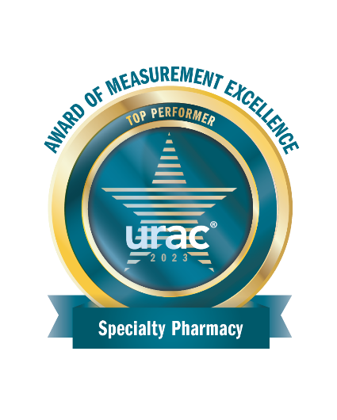
Optime Care Receives URAC Top Performer Credential: Transforming Healthcare Through Measurement Excellence

St. Louis, MO – June 20, 2024 – Optime Care, a nationally recognized specialty pharmacy and an AscellaHealth Company, is pleased to announce that it has earned the prestigious Leaders in Performance Measurement award from URAC, the nation’s largest independent health care accreditation organization. URAC recognizes leaders who demonstrate commitment to improving healthcare quality through performance measurement and continuous quality improvement (CQI) to enhance the health and well-being of the populations they serve.

“We are honored to receive URAC’s performance award which recognizes our role as a trusted industry leader and further validates our team’s commitment to instituting policies and procedures that ensure the highest quality care and optimal clinical outcomes for all patients,” says Stephanie Wasilewski, PharmD, general manager, Optime Care. “Through ongoing performance measurement activities, we document the improvement of processes, safety and quality of patient care.”

Optime Care specialists are expert communicators who optimize the patient journey, providing clinical guidance and valuable assistance to patients and families. They streamline care coordination, help with insurance coverage, address financial needs and identify financial assistance programs to improve patient access to therapies.
“Our experience with small patient populations and managing the specific needs of patients with chronic, complex diseases, coupled with being an AscellaHealth Company, enhances our services and ability to serve the specialty pharmacy market,” continues Wasilewski. “Collectively, the outstanding performance of our professional team results in better clinical outcomes.”
The Leaders in Performance Measurement awards program highlights the URAC-accredited organizations that are effectively using performance measurement to improve the health and well-being of the populations they serve. A Top Performers designation demonstrates an organization is recognized for high performance in submitted measures with excellent work and a demonstrated quality. URAC assesses the performance of pharmacies of all types and sizes, all of which are eligible for the award – from small and independently owned pharmacies to large organizations.
About Optime Care
Optime Care, Inc., an AscellaHealth Company, is a nationally recognized specialty pharmacy, distribution and patient management organization offering a suite of comprehensive services tailored to maximize therapeutic opportunities for the treatment of orphan and rare disorders. The executive team has partnered in the launch and management of over 40 orphan products and programs while consistently implementing the best brand services for the community. Optime Care has dual-accreditation from the Utilization Review Accreditation Commission (URAC) for compliance with specialty pharmacy and the Accreditation Commission for Health Care (ACHC) for specialty pharmacy services that demonstrate a commitment to providing quality care and services to consumers. Visit www.ascellahealth.com
About URAC
About URAC Founded in 1990 as a non-profit organization, URAC is the independent leader in promoting health care quality and patient safety through renowned accreditation programs. URAC develops its evidence-based standards in collaboration with a wide array of stakeholders and industry experts. The company’s portfolio of accreditation and certification programs span the health care industry, addressing health care management and operations, pharmacies, telehealth, health plans, medical practices and more. URAC accreditation is a symbol of excellence for organizations to showcase their validated commitment to quality and accountability.

